**AS91370**

Website Development

*Planning Document*

*By Matthew Jakeman*

Preface

*“You are to create a website for a producer of an artisan food (for example cheese, sausages, bread) or beverage (for example boutique beer or cordial) in your area. You will create the digital media content (for example backgrounds, buttons and banners) and integrate at least one other media type (such as your own photos or graphics).*

*The specifications for the website include:*

* *background information about the company*
* *location and contact details*
* *branding (logo, colours, fonts)*
* *images and a list of products with descriptions and prices*
* *stockists or purchase systems*
* *recipes*
* *media coverage and/or awards.*

*Ensure that you address any legal, ethical and moral responsibilities.”*

*– Achievement Standard*

Technologies

I started this task by choosing which technologies to base the website on. While I have primarily used HTML5/CSS in the past, I found that they are, by themselves, severely limited when it comes to dynamic websites (the number of pages is not fixed, for example, there might be one page per product). Because of this, I decided to create my website using PHP7, the latest version of PHP: Hypertext Processor, in addition to HTML5 and CSS. I examined the benefits and trade-offs of using this technology, before coming to the decision.

**Advantages**

* Adds JavaScript-like logical capabilities to the website, without having to execute in-browser. Additionally, will not cause any client-side lag, as all logic is executed before delivery (server-side).
* Can run on HTML-only browsers.
* Objectively has the best support for MySQL Databases.
* Makes reusing HTML and creating templates incredibly easy.
* PHP Includes mean that website widgets (eg. Navigation) will never vary from page to page.
* Can facilitate the creation of a content management system.

**Disadvantages**

* ***Requires a web server to operate.***
* May open possible security holes.

Web Server

As shown above, PHP requires a web server to execute. For developmental purposes, I chose to use XAMPP (**X**-Cross **A**pache **M**ariaDB **P**HP **P**erl) which is a cross platform Apache stack for Windows, Linux, and other platforms. I chose this as I plan to switch between Linux and Windows to test the website’s font rendering (Linux renders fonts slightly differently from Windows and Mac), and this will allow me to run the website on the majority of systems.

Editor

I also chose the text editor I would work with for this project. Initially, I planned to use Emacs – my general purpose text editor – with the PHP Mode plugin, however after trying it in combination with HTML, I found the syntax highlighting to be extremely poor. Because of this, I decided to use Visual Studio Code for this project, as it has first-class support for PHP*.* Visual Studio Code runs on both Windows and Linux, and has built in support for a wide variety of file types, making it ideal for this kind of project.

Other Software

**Image Editor**

I will use Inkscape to create the graphics, as it is a free and open source tool, and is freely accessible. Additionally, it provides vector functionality, meaning that images will look good and be readable on all display sizes. This is opposed to raster images, which become blurry at higher resolutions.

**Image Converter/Resizer**

For resizing and converting images, I will use the freeware tool FastStone Image Resizer, as it provides the ability to easily mass-manipulate large amounts of images.

**Raster Editor**

For raster images, and to create effects that are not easily possible with Inkscape, I will use GIMP. I chose GIMP as it is the most advanced open source image editor, and I am very familiar with it.

Requirements

To start with, I created a list of website features required by the Achievement Standard:

**Basic Information**

* Multiple page website
* For producer of artisan food
* Create digital media content (backgrounds, buttons, etc)
* Integrate another media type (photos, graphics)

**Features**

* Background information about the company
* Location and contact details
* Branding (logo, colours, fonts)
* Images and a list of products with descriptions and prices
* Stockists or purchase systems
* Recipes
* Media coverage/awards

Plan

My website will be that of an Artisanal Cheese producer.

**Components**

There will be three main pillars of my website:

* Discovery
* Shop
* Portal

The discovery section of the website will allow the user to learn about and explore the hundreds of different cheeses from around the world. It will consist of an interactive image map which directs the user to the store front when they click on an item.

The shop section will allow the user to purchase branded artisanal cheeses from an easy to use web interface. Additionally, it will have a working cart and automatic price tallying system.

Finally, there will be an Administrator’s Portal which allows an employee of the company to easily update the contents of the store database without having to use phpmyadmin or a similar tool.

**Branding & Identity**

For the company’s branding, I wanted to echo the look of cheese. I used serif fonts to create an ‘old-timey’ look, combined with script fonts for an elegant appearance and contrasting shades of yellow to enhance readability. I decided on the following colours for the website:

| Colour | Value |
| --- | --- |
| Cheese Yellow | rgb(245,192,18); |
| Cheese Yellow Dark | color: #dfaf11; |
| Cheese Yellow Accent | color: #f5af19; |
| Damage Red | color: #e31a1a; |
| Damage Red Dark | color: #e31616; |

Cheese Yellow will be used for the navigation bar and main user interface elements, Cheese Yellow Accent for borders and transition effects, Cheese Yellow Dark for complementing the main colour and as hover effects, etc, Damage Red for warnings and errors, and Damage Red Dark for hover effects.

**Naming Convention**

For the MySQL Database, I will use Prefixed Camel Case (PCamelCase), where the first letter represents the type of object. This means that a cheese table would be ‘TCheeses’. For table fields, I will use snake case, with the table name prefixed at the front to avoid ambiguity. The id field of the previously mentioned TCheeses table would be called ‘cheese_id’.

**Mockups**

I began by creating a few mock-ups for the website using Inkscape. I decided on the different ‘components’ of my website, and established the colour scheme and ‘look-and-feel’ I wanted.

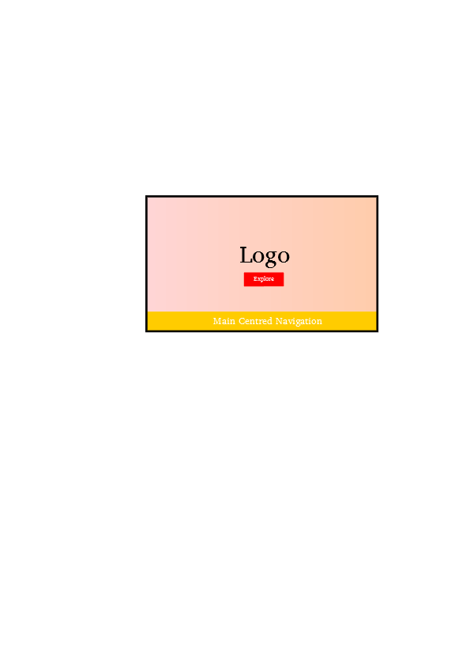

**Figure (Left):** The splash screen presented to the user when they first enter the website. The navigation is at the bottom here, scrolling with the page. I opted not to make the navigation sticky, but I may add a ‘Go to Top’ button that is fixed, or in the footer.

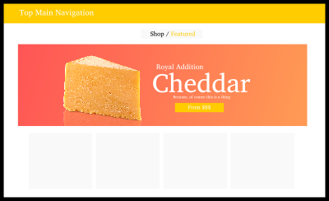

**Figure (Left):** The store front, which offers custom branded artisanal cheeses. There will be a featured cheese in the ‘hero image’, and then a gallery/grid of other available cheeses.

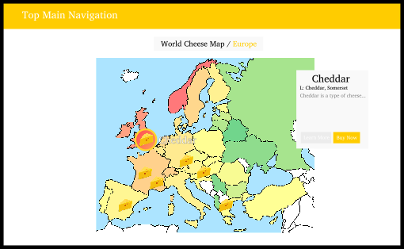

**Figure (Left):** The regional cheese map. There will be one for each of the six inhabited continents, and small cheese icons will be placed on various regions from where notable cheeses come from.

Note: The map background will expand to fill the entire screen, as to better immerse the user in the experience.

**Figure (Left):** The regional cheese map. There will be one for each of the six inhabited continents, and small cheese icons will be placed on various regions from where notable cheeses come from.

Note: The map background will expand to fill the entire screen, as to better immerse the user in the experience.

**Sprints**

Today, I started work on the actual website. I decided to structure the project using the Software Engineering concept of Sprints. Each Sprint focuses on a particular feature or aspect of the project and will run to completion. My plan can be seen as follows:

* **Sprint One** – Main Website – This sprint focuses on the pages for home/splash, about, contact, etc. This will facilitate the creation of a template system using PHP.
* **Sprint Two –** Store Front – This sprint will focus on the creation of a Content Management System with PHP, which will allow for products to be added and removed from a database, updating accordingly. This will require an image delivery system to associate images with the database and to fetch them from anywhere in the site. It will also need an administrator portal page, allowing the company to manage products through a web interface.
* **Sprint Three –** Interactive World Cheese Map (IWCM) – This sprint will involve using the database from the previous sprint to create an IWCM, which will essentially get the user to browse the store front in a fun and interactive way.
* **Sprint Four –** Polish & Compliance – This sprint will involve the final implementation of features and content to make the website fully satisfy the criteria provided in the Achievement Standard.

Sprint One

Main Website

*This sprint focuses on the pages for home/splash, about, contact, etc. This will facilitate the creation of a template system using PHP.*

I created the root directory of the website. Inside here, I created three more directories:

* docs – For documentation, such as this planning document.
* public – The user facing content of the website. This is the ‘htdocs’ equivalent in my project.
* resources – The configuration, templates, etc that are used by the website.

**Templates**

As the entire reason that I chose PHP was to reduce repetition and ease development, I wanted to make my site as reusable as possible from the beginning. I decided to minimise as much boilerplate as I could by moving it to a single location, so that if I wanted to change one aspect of the website, I would not have to go through every single page to update it. I decided to create a ‘config.php’ file inside the resources directory which will be included at the top of every page. This script will contain a series of helper functions for defining regular page headers, etc.

I started by creating the function ‘generate_head’. This function takes in a string called ‘title’ and uses it to format the page title shown in the tab of the browser. It also hard-codes in the charset and css stylesheets, so changing them in one place, updates them everywhere. I created a global variable called ‘TITLE_FORMAT’ which contains the title template in printf syntax. The function looks as follows:

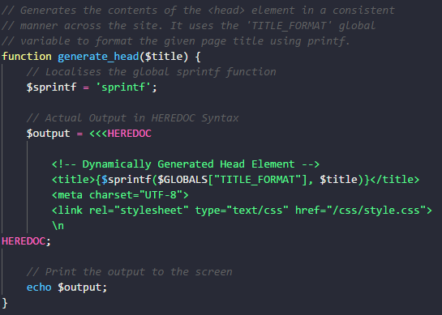

**Splash**

First, I wanted to make the splash page of my website. Using the mock-ups above, I created the splash portion of my home page. It consists of two parts, a container div with a background image, and an overlay div which is positioned above it. For the background image, I chose to use a royalty free image of various cheeses I found on the internet. I added an ::after element using css, which I positioned on top of the background and added a semi-transparent gradient to. This makes the overlay ‘pop’ more. I decided to have the container take up 90vh of the screen (90% of viewport height), leaving 10vh for the navigation.

I created an anchor element and styled it to ‘glow’ on hover, and have the text shift to the left, with a ‘>>’ appearing to the right. Finally, for the logo, I decided to create a temporary version in GIMP, before doing a final version in Inkscape later on. I used GIMP’s paths to warp text around a centre. I used the font ‘Luna’ for the logo, in conjunction with some Roboto Slab. The Splash part of the home page looks as follows (Red border for visibility):

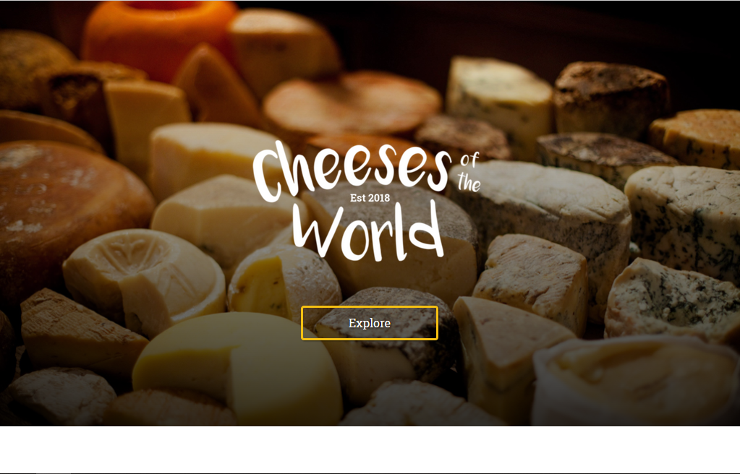

**Navigation**

For the navigation bar, I decided to make this component reusable. I created a new folder in resources called templates, and created the file ‘navigation.php’ inside it. I created a function which I called ‘internal_navigation_item($title, $href)’. This function takes in the title and href of a page, compares the href to the script name, and decides whether or not the list item should be highlighted. This way, I can add as many pages as I want, and the current page will always be highlighted if it is part of the navigation bar. I again used the font ‘Luna’ for the text. I decided on four pages: ‘Home (Current)’, ‘Cheese Map’, ‘About’, and ‘Shop’.

For the styling, I made the navbar cheese-yellow, with a slightly darker yellow line on top. I then made the current item that same colour, to have a ‘tab’ like appearance. Finally, when hovering over any of the items, the text’s opacity increases. For the current tab, the text gains a white text-shadow to create a ‘glow-like’ effectThe navigation bar looks as follows:



**About Page**

After finishing the Splash portion of the Home page, I moved on the About Page. I created a new file ‘about.php’, and pasted the contents of ‘index.php’ into it, again removing the splash so that the navigation was at the top. I made a quick cosmetic change to the navigation, switching Luna for Dancing Script, as I felt that it looked more ‘elegant’. I kept Luna for the logo however, as I wanted the ‘hand-drawn’ appearance. I also decided to swap out Roboto Slab for my long time favourite Charis SIL, which is a freely redistributable font licensed under the SIL Open Font License. I manually added this font inside ‘css/fonts’, and imported it in via a ‘fonts.css’ file.

I prototyped the layout in Inkscape, before implementing it. I aimed to go for a cross between the store page’s hero image, and a newspaper-like two column layout.

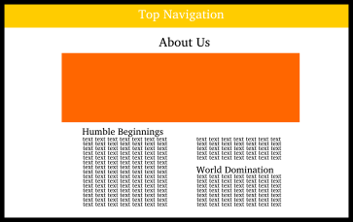

For the hero image, I used a picture of a cheese store in Amsterdam licensed under Creative Commons Attribution. I added the copyright information into a markdown document for when I implement the footer. I separated the CSS into two individual classes: hero, and about-hero, so that I can reuse the hero image for the shop later on. I added a gradient overlay positioned absolutely over the image, going from dark-grey to transparent, top to bottom. I then positioned some text over the image (as opposed to above, like in the mock-up).

Next, I worked on the multicolumn layout. I used CSS Columns for this, making sure not to use column-span due to poor browser compatibility. I split the page into three columns, and added spacing between them. The hero image and newspaper layout look as follows (Red border for clarity):

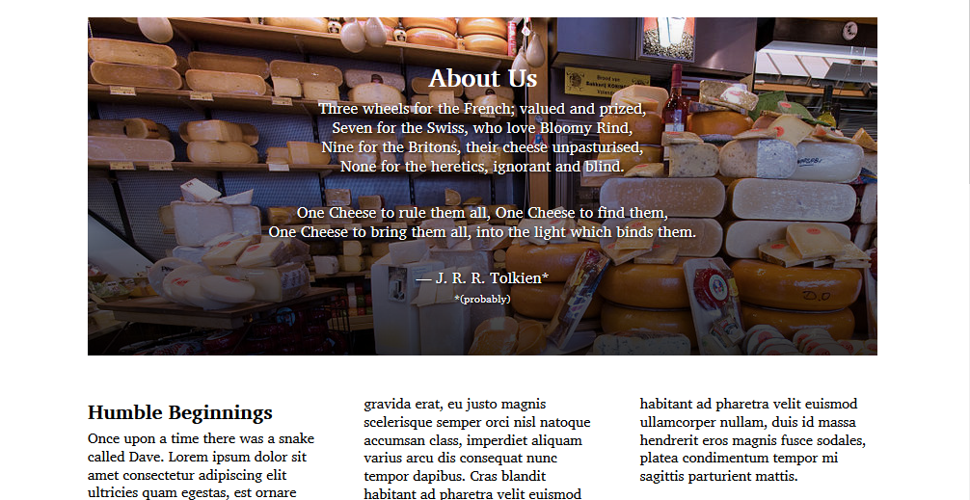

While I am very happy with the layout of the page, I felt the background was rather bland. I decided to create a cheese-themed background pattern in Inkscape that I could repeat on the page. I decided to find inspiration online, and used ‘Leaves Pattern’ by Constantin Galaktionov from Subtle Patterns as a base for my own.

Firstly, I decided on having three unique shapes that I would repeat across the page. The first would be a cheese slice, the second a cheese wheel, and the third a cracker.

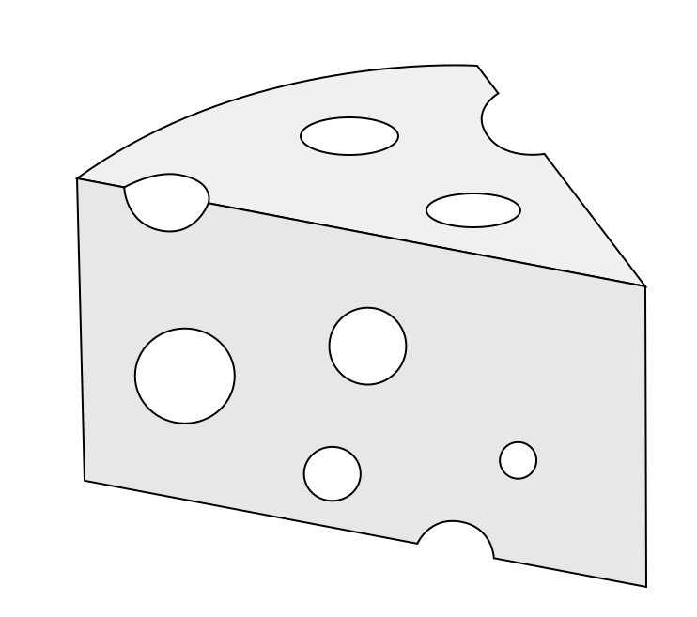Cheese Slice

I first started with the outline of a slice of cheese (a 3D sector of sorts), and made some slight circular indentations to show the holes on the edges. I then subtracted some circles from the final vector shape to create the cheese effect and coloured it a light grey colour.

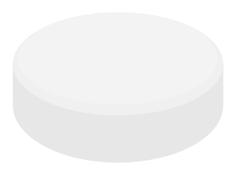Cheese Wheel

I created this by creating an oval, duplicating it and moving it upwards, and then duplicating the top circle again and making it smaller. I set the three ovals to be different shades of grey. I decided against the black border, removing it here, and from the above cheese slice.

Cracker

For the cracker, I created a circle, made dozens of small holes in it by path exclusion, and then duplicated it and offset it slightly with a darker shade of grey.

Background

Finally, for the background, I arranged the three in a triangle, and cropped the canvas around them. I made the background a very light shade of grey, and tested it out. I found that the shapes were too noticeable, so I reduced the lightness of the background. Once I was satisfied with that, I noticed that the background was too repetitive. I duplicated the three objects and made a random nine by nine arrangement of them. The background looks as follows:

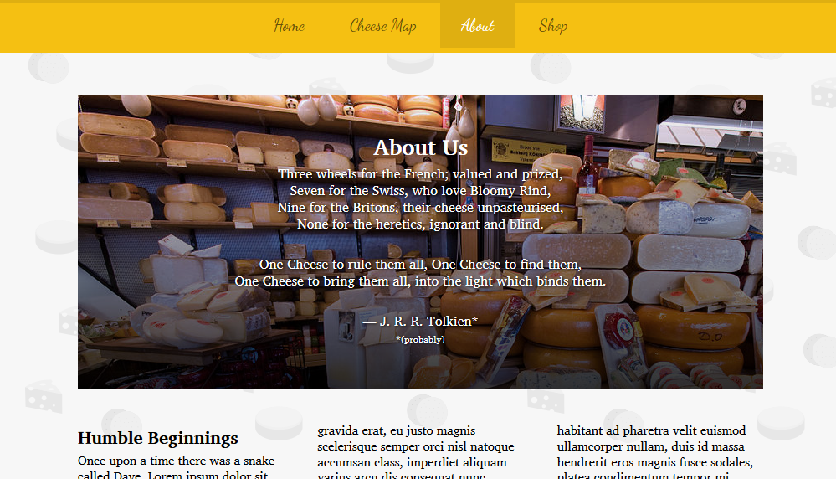

I then added a contact section to the page. For this, I decided to go with a two column layout. On the left would be an HTML form for submission, while on the right, there would be a description and some contact info, such as email, phone number, address, etc. For the form, I used two input boxes, a text area, and a submit button. I used the same yellow colour I have been using for the navigation as an accent. The left side of the form looks like this:

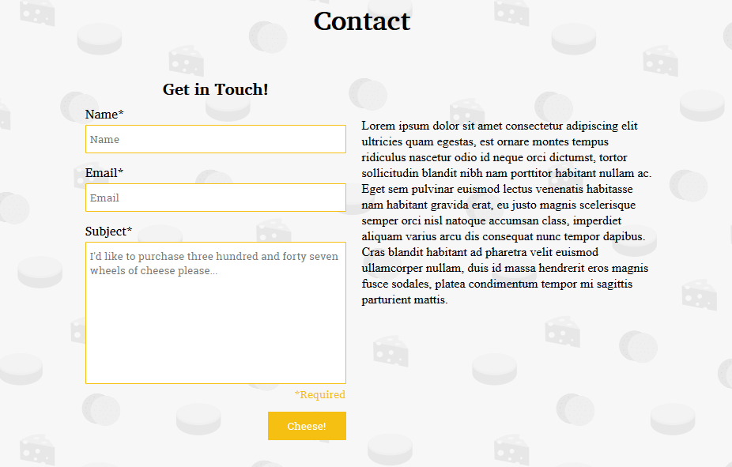

For the right hand side, I created some ‘info widgets’ for location, phone, and email. I used Firefox Photon Design Icons from <https://design.firefox.com/icons/viewer/> for the icons initially, however I felt that the icons were inconsistent using fixed width. I opted to use material design icons instead, from <https://material.io/tools/icons/?style=baseline>. The contact form looks as follows:

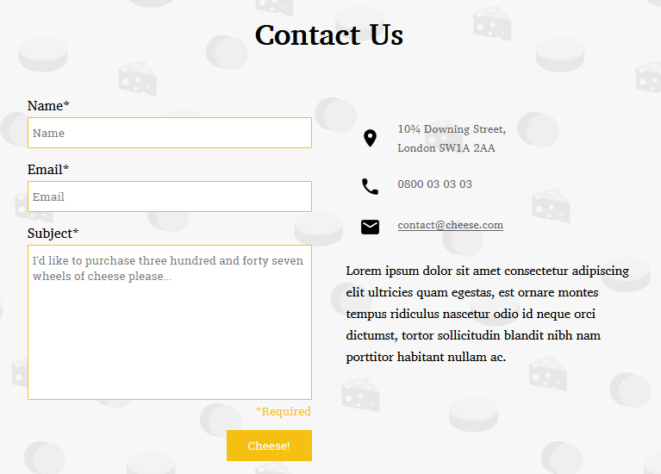

I plan to fill out the actual information (instead of placeholder Lorem Ipsum) at the end of the project, once the fundamentals of the website have been completed.

Finally, to finish off the about page, I created the footer. I took inspiration from the ‘Microsoft Footer’ from <https://www.microsoft.com/en-nz/>, which is a multicolumn list of pages organised by heading. This is the type of footer I aim to recreate:

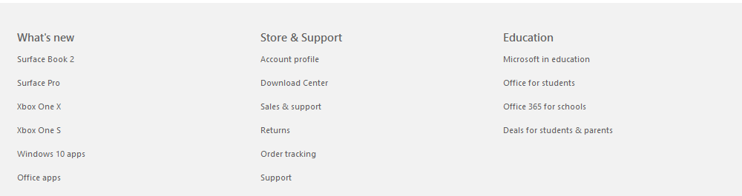*(From the Microsoft website)*

In the same way that I created the navigation, I created a footer.php and modified the functions to create the footer. I have three main functions: internal_footer_item(), which takes a title and href and returns a list item, internal_footer_column(), which takes a title and an array and generates an unordered list, and internal_generate_footer(), which calls both of those functions to actually generate and output the footer’s HTML. I also worked on an ‘attributions’ and ‘copyright’ section for the footer, styling them with the same colours as the navigation bar. For the copyright section, I set the second date to update automatically using the PHP ‘date’ function. The unfinished footer looks as follows:

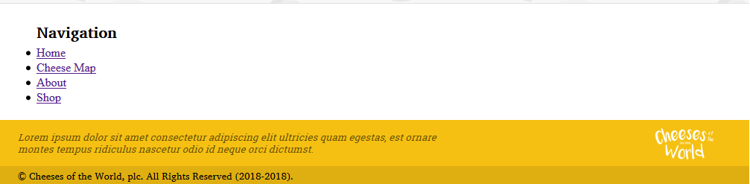

For the footer styling, I made the background a light grey. I removed the bullet points from the list items, changed the font to Charis SIL, and then modified the spacing between list items. I also added another column for Cheese Map shortcuts, and for Social Media. Finally, I added a one pixel yellow border at the top to clearly mark where the page ends and the footer begins. The finalised footer can be seen in the following picture.

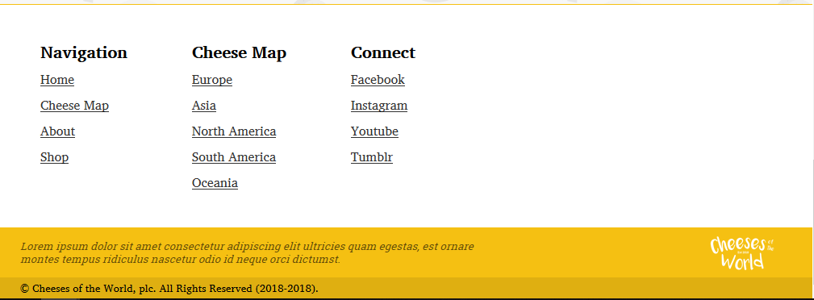

**Home Page**

My initial plan was to make the Home Page have into two different sections, divided by the navigation. The top ‘Splash’ area, and an awards area below that. Having used the website more, I decided against this, as I felt the non-scrollable home page created the impression that it was some kind of ‘Gateway’ into the website, as opposed to yet another page. I plan to incorporate this awards feature into the store instead, or possibly a separate page, if I choose so in the future.

Sprint Two

Online Store

*This sprint will focus on the creation of a Content Management System with PHP, which will allow for products to be added and removed from a database, updating accordingly. This will require an image delivery system to associate images with the database and to fetch them from anywhere in the site. It will also need an administrator portal page, allowing the company to manage products through a web interface.*

Before starting, I thought about how I would achieve a shopping cart system, as this is something that I really want to implement, to achieve as close to a real functional online store as possible. Additionally, I need to have an administrator web interface for manipulating the store database. I decided on a secondary navigation bar underneath the main site-wide navigation. For this design, I took inspiration from Nautilus, the file browser for Gnome:

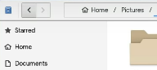

I will have a full-width grey-ish bar, with a usable section in the centre. ‘Action buttons’ will be floated to the left and right, and a pathbar/breadcrumbs widget will be in the centre. I created a new mock-up of this in Inkscape, based on my previous store mock-up:

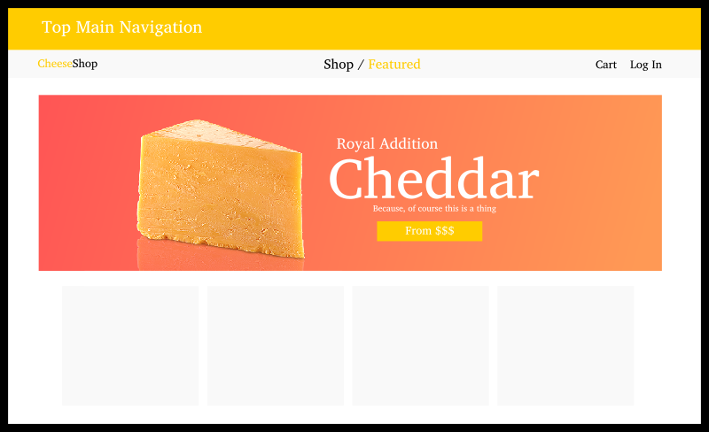

I started by duplicating the contents of About, and removing the Contact and History sections. I copied the CSS and renamed the classes to start with ‘shop’ instead of ‘about’. I changed the contents of the Hero Image to match the above picture. I split the hero image overlay into two separate containers, split equally along the vertical, inside a flexbox. I made the left hand container have a centred piece of cheese, while the right hand side has the description and text. I created a special button based on that from the Splash screen. When hovering over the button, an arrow appears to the side to provide user interaction feedback. The HTML version of the above image can be seen here:

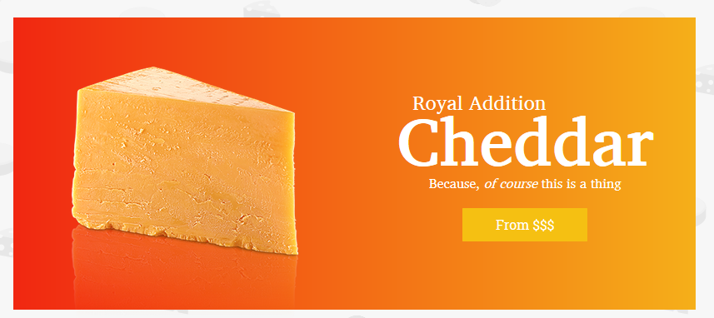*Actual website-version of the hero-image*.

Next, I focused on the secondary navigation. Since this will be used across multiple pages (store home page, log in, cart, admin, item listing, etc), I felt it was important to make it reusable easily. I created a php file called ‘store-nav.php’ in the templates directory, and added a function ‘internal_generate_store_nav()’ to automatically insert the secondary navigation bar. For the store navigation itself, I created a three divs inside a nav element. I floated the first div left, the third div right, and set margin to be automatic for the middle div. As well as achieving the layout I wanted, the middle div serves as a ‘clearfix’ of sorts for the floated elements, as they are all the same height.

Currently, I have reached the point where I cannot do any more work on the store, until I incorporate a database. I enabled the MySQL server in XAMPP, and created a basic framework using phpmyadmin. I created a database called ‘cheese_shop’ using the ‘latin1_swedish_ci’ collation/charset.

I created a table ‘TCheeses’, with an initial four columns. I added two sample cheeses to establish an initial connection with MySQL from PHP:

| cheese_id | cheese_name | cheese_price | cheese_description |
| --- | --- | --- | --- |
| 1 | Cheddar | $12.95 | Delicious English Cheddar hand-crafted in Somerset for your enjoyment. |
| 2 | Stilton | $34.95 | Authentic Blue Stilton, crafted in the county of Derbyshire. Certified origin. |

I created a new template file which I called store-grid.php. In here, I created a div container, which acts as a flex-box, and a php function to populate it with ‘cards’ representing each cheese in the database. With PHP, there are three different ways to connect to a database: MySQLi Object Oriented, MySQLi Procedural, and PDO (PHP Data Objects). I chose to use MySQLi Procedural, as I am more comfortable with C-style programming than OOP. I used the default username and password for MySQL: “root” and “”.

In store-grid.php, I created a function called internal_generate_store_grid($length), which takes in the length of the store grid that is wanted in individual elements. It connects to the database, using variables stored in the global configuration array, and iterates through the ‘TCheeses’ table using a hard-coded SQL query. At the beginning and end of the function, it outputs div tags, marking the start and end of the store grid section. For each record in the cheeses table, it outputs a ‘card’ which contains information about the cheese (Name, Price), and has a placeholder for an image. I also created another function called internal_generate_grid_item() to reuse the card generation code.

I styled the grid items to have two different sections: an image header, and a body with the title of the cheese and its price. I gave the item a box shadow, which increases in opacity and spread once hovered on. I fixed the image size at a 4:3 aspect ratio and created a placeholder image for the mean time. The grid item looks as follows (left normal, right hover):

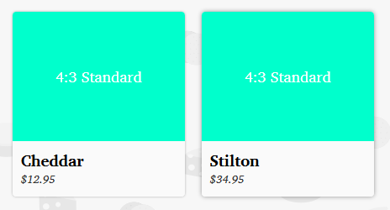

Now that I had the basic grid item system working, I decided to work on a filter system. This will allow the user to filter the entire list of items (which I plan to have on the shop page) by country, etc. It will comprise of a single horizontal bar, the same length as the hero image, underneath it, which is an HTML form. It will allow the user to set filters, clear all filters, and will act on shop.php, regenerating the store grid.

I created the bar as a div, with a form element inside. I aligned the elements horizontally, and made it have a light grey theme with yellow accents. For the various filters, I chose “Origin”, “Flavour”, and “Milk Type”. I also added a Clear button and a Filter button at the end. The filter bar looks as follows:



I also created an additional form and select element for choosing the ordering method. I added ‘None’, ‘Price (Ascending)’, ‘Price (Descending)’, ‘Alphabetical (Ascending)’, and ‘Alphabetical (Descending)’. I styled this to be centred underneath.



While I really liked how this turned out, it was impossible to use without JavaScript. I ended up having to add a submit button that would execute the form underneath it. I did not like the effect this had on presentation. I scrapped this idea, and redid the design to be more vertically compact.

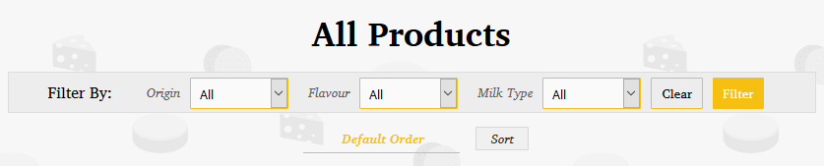*The finalised filter and sorting widgets.*

**Backend and Validation**

Next, I had to hook up the filtering and sorting system to the backend. When either the clear, filter, or sort buttons are pressed, the page will reload, and (key, value) pairs will be updated in the url. I decided on having the following (key, value) pairs:

| Key | Values |
| --- | --- |
| sort_by | 0 (Default), 1 (Alphabetical A), 2 (Alphabetical D), 3 (Price A), 4 (Price D) |
| cheese_origin | From Database |
| cheese_flavour | From Database |
| cheese_milk_type | From Database |

The following events will happen upon clicking one of the three buttons:

| Button | Event |
| --- | --- |
| Sort | Sorts by the value of the ‘sort_by’ <select> tag, and updates the ‘sort_by’ variable to match. |
| Filter | Adds variables to the url for each of the selected filters. |
| Clear | Strips the URL of all variables, including ‘sort_by’, to return to the default. |

I started by hooking up the forms to act on the current page. I used the PHP superglobal ‘$_SERVER[“PHP_SELF”]’ for both the Filter and the Sort forms. I then encountered another problem, in that a string was being submitted rather than an index. I created a new template file which I called select.php, and inside it, a function called ‘internal_generate_select($name, $array)’. This function accepts a name for the control (to appear in the url), and an array with (int, string) pairs for the <option> tags inside it.

I then extended this function by allowing it to select a given entry to be default. I added another argument called ‘selected’ which takes in an integer. It then matches that with the array, and adds the ‘selected’ attribute on the correct <option> tag. If the value exceeds what is available, no tag gets the selected attribute, and the browser defaults to the first item. This is expected behaviour.

Finally, I added some PHP that would get the ‘sort_by’ pair from the url, check the value, and pass that value to the function for selection. This way, the combo box will always show the active sorting method on page load.

**Validation** – I used the ‘htmlspecialchars’ function to validate the url entry, and remove any <script> tags passed through. This is because XSS (Cross Site Scripting) could occur and potentially compromise the website and user safety.

In order for the sorting to actually work, the function ‘internal_generate_store_grid($length)’ must also be able to accept an SQL query as input. This query will be generated on page load from the (key, value) pairs in the url. It will then be submitted to the store grid generation function for creating and displaying a grid that matches the filter criteria. I removed the local $sql string, and made it a function argument. I then passed in that same string from shop.php, and made sure the website still worked correctly.

I set the length of internal_generate_store_grid to a hard-coded 1000 cheeses (more than will reasonably exist at any one time). In the future, this variable would allow the shop to implement some sort of pagination. For example, they may only want to display 25 cheeses per page to avoid heavy data usage and wasted bandwidth. This allows the basic framework of the shop to be future-proof.

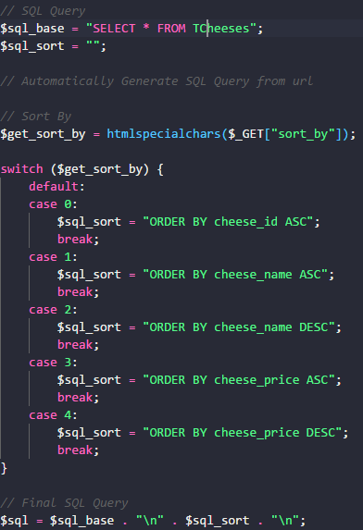I then focused on generating the SQL query from the GET variables in the url. I started with sort_by. I first got a safe version of the value from the url through ‘htmlspecialchars’, before processing it with a switch statement. For each of the five possible values, I generated a certain SQL string. In the case of a value that did not fit, I defaulted to the default sort. A snippet of the SQL generation can be seen as follows (right):

In order to implement the filters, I needed to greatly expand the database. I needed to add more samples to test the filters, and more importantly, the filters themselves. I decided to add the following foreign keys to the database. All of the fields are on the many side of a one to many relationship.

| Field | Description |
| --- | --- |
| cheese_flavour_id | A foreign key to a TCheeseFlavour table. |
| cheese_milk_type_id | A foreign key to a TCheeseMilkType table. |
| cheese_origin_id | A foreign key to a TCountries table. |

This necessitates the creation of the following tables:

| Table | Description |
| --- | --- |
| TCheeseFlavour | Contains one record for each type of cheese flavour (eg. Mild, Strong, Stinky). |
| TCheeseMilkType | Contains one record for each milk type (Cow, Goat, etc) |
| TCountries | Contains one record for *each and every* country in the world. Each record contains a Foreign Key to a continent from TContinents. |
| TContinents | Contains one record for each of the world’s habitable continents. |

As I was unable to find a definitive resource for cheese classification, I opted to use an Artisan Cheese website as a base for the data entry. I used ‘<https://www.formaggiokitchen.com/shop/shop-online/artisan-cheese.html>’ for details about various types of cheeses.

I started by adding the countries. As I plan to have a web interface, I will need to have every single country in the world registered in the database. I first created TContinents, with the following columns and records:

|  |  |
| --- | --- |
| **Field** | **Description** |
| continent_id | The primary key/unique id of the continent. |
| continent_name | The name of the continent stored in plain text. |

I decided to group countries by region instead of continent, due to issues surrounding Eurasian countries and the Middle East. I renamed the table to TRegions, and the fields to start with the region_ prefix. I decided Russia should be a European country as it is culturally closer to Europe, despite being primarily in Asia. When adding the individual countries, I decided to recognise Taiwan as a region separated from mainland China. I also added Greenland as an independent country, despite it being an overseas territory of Denmark, as it is in a different part of the world geographically, and is culturally closer to North America.

I used this data to hook up the filter system, and tested it with some test data. The actual filtering of data was based on the system used for sorting. I took a base SQL statement, and appending additional statements for each of the sorting options, until the query was complete. The queries for each of the filters are as follows:

| SQL | Query |
| --- | --- |
| Base SQL | SELECT * FROM (((TCheeses INNER JOIN TCountries ON TCheeses.cheese_origin_id = TCountries.country_id) INNER JOIN TFlavour ON TCheeses.cheese_flavour_id = TFlavour.flavour_id) INNER JOIN TMilkType ON TCheeses.cheese_milk_type_id = TMilkType.milk_type_id) |
| Cheese Origin | WHERE/AND TCountries.country_region_id = $get_origin |
| Cheese Flavour | WHERE/AND TFlavour.flavour_id = $get_flavour |
| Cheese Milk Type | WHERE/AND TMilkType.milk_type_id = $get_milk_type |

I decided to rename TCheeseFlavour and TCheeseMilkType to TFlavour and TMilkType respectively. I conditionally set the beginning of the latter three statements to WHERE or AND depending on whether it was the first occurence.

**My SQL Error Messages**

In the case that MySQL is unable to connect to the database, I would like to output an error informing the user/admin, so that it can be corrected. I created an error message for ‘Connection Error’, ‘Query Error’, and ‘No Results’. They can be seen below:

*Connection Error*

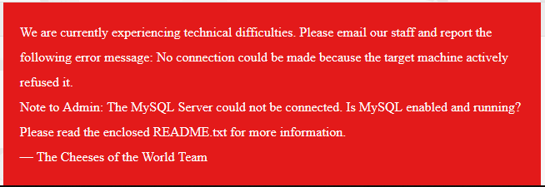

*Query Error*

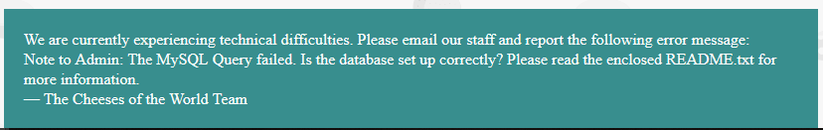

*No Results*

**

**Item**

Now that the main store page is completed, I moved on to working on the individual item pages. These should show an image of the product, a description, the price, the name, and a button to add it to cart. I duplicated About again, removing everything except for the header and footer. I created two ‘panes’. A main panel and a sidebar, which contain product information, and purchase information respectively.

For the main panel, I added the title of the cheese, an image (for which I used a 16:9 aspect ratio placeholder created in Inkscape), a ‘Quick Facts Bar’, and a description. The Item page looks as follows:

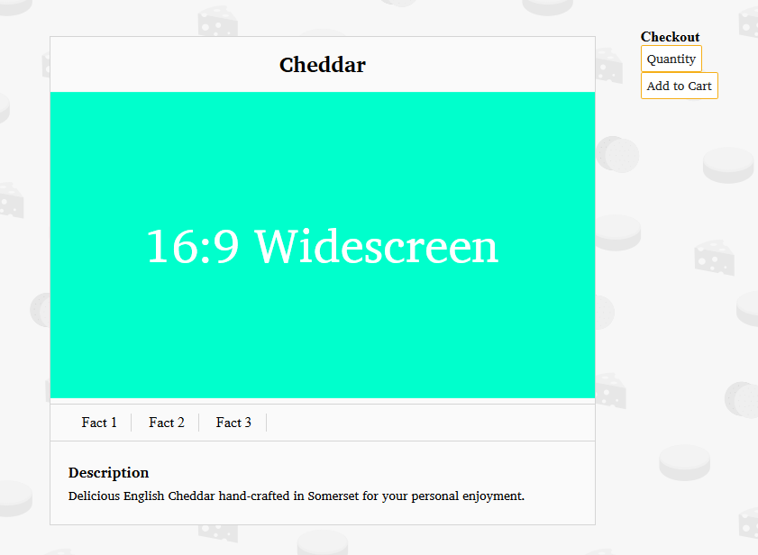

For the sidebar, I added a quantity number input and an add to cart button. I made them take up the full width of the sidebar. Additionally, I added the item’s price in large text above the two. I decided to rename ‘Checkout’ to ‘Purchase Item’ for clarity. The finalised item template, using data from the ‘Cheddar’ cheese can be seen below:

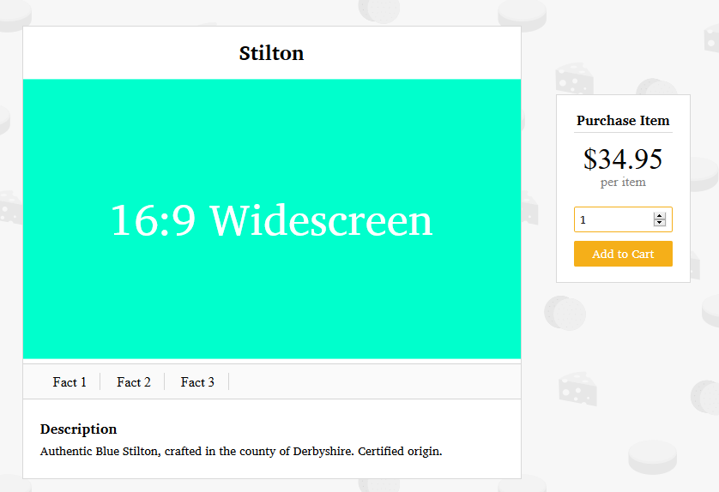

**Cart System**

To create an actual, functional cart, I first needed a way to store data between pages. I decided to use PHP sessions for this. At the top of ‘config.php’, I added the line ‘session_start();’, which will be called for every page on the site.

In order to add an item to the cart, I needed some form of user interactivity. I decided to use an HTML form which navigates to a PHP page called ‘add-to-cart.php’. This page takes (key, value) pairs in the URL, which it then uses to add the specified item to the cart. Finally, it redirects the user to a given page, also passed as an argument. I used the $SERVER_NAME global variable as the root URL, so that I could redirect to the proper website. If the server name is changed, this will also need to change, for the site to work properly. I decided to rename this variable $ROOT_URL to better reflect its nature.

The cart system itself is based around a session variable called ‘cart’. This array contains (item_id, quantity) pairs. When an item is added or removed, or has its quantity updated, this array will be manipulated.

Inside ‘cart.php’, the page that will show the cart contents, I added a function to generate a single horizontal ‘item’ with quantity and remove controls. I then called this function in a loop to generate the entire cart at the current time. I opted to use an HTML table for this, to provide a clear and sane way to display the information. I based my design on Amazon’s shopping cart, choosing to have a large square picture on the left-most column, with the product’s name, price, and quantity to the right. Finally, I made the table rows have alternating colours for visibility. The cart looks as follows, with some sample items:

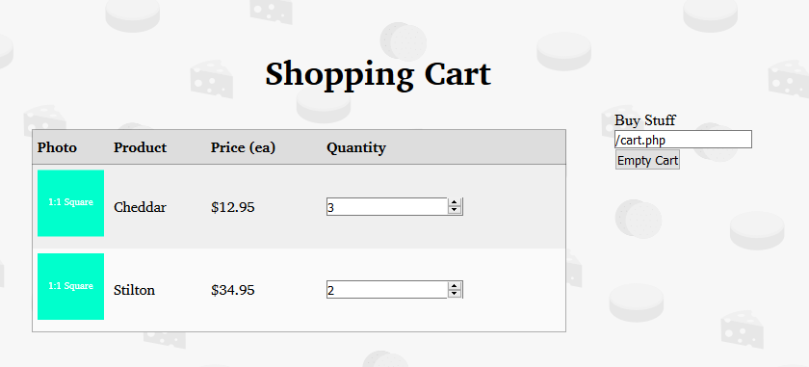

I added the cart to the store navigation bar, and added a live preview of how many items are in the cart (this was done through a foreach loop which accessed the quantity value of each item in the arrray). I decided to rename ‘add-to-cart.php’ to ‘cart-add.php’, and also added a ‘cart-remove.php’ and a ‘cart-reset.php’ for removing items and emptying the cart respectively. The cart reset page simply unsets the ‘$_SESSION[‘cart’]’ variable, while the remove page searches the array for the specified item id, and if found, unsets the specific key, value pair.

Finally, I added some error handling. In the case that the cart is empty, the following message is shown to the user:

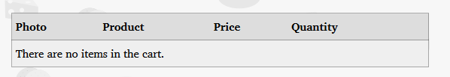

For the final column, I added a ‘Remove’ button, which removes the selected item from the cart. It consists of a simple HTML form that redirects the user to ‘cart-remove.php’. The form looks as follows:

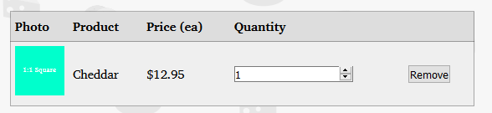

I also added the store sub-navigation to the cart page.

**Checkout**

Next, I finished up the checkout section. This section simply provides options for emptying, updating, and purchasing the contents of the cart. I also added a quick tally for prices, and added a handling/convenience fee of 15%. The checkout sidebar looks as follows (right):

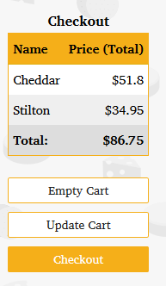

The checkout button navigates the user to a new php script called ‘checkout.php’ using POST for security. This page does not perform any further action with the data, as that is outside the scope of this assessment. It then redirects the user to a page which informs them that their order has been placed, and provides a link to return to the home page.

**Quantity Controls**

Next, I worked on wiring up the quantity controls for cheeses. I encountered a problem with how I had designed the cart system. I had multiple quantity input fields, but only one update cart button, making this near-impossible without JavaScript. As I did not want to sacrifice compatibility and performance, I decided to remove the ‘Update Cart’ button, and add an update quantity button next to each quantity setting. Additionally, I changed the styles of Update and Remove to match the buttons in the checkout. The new cart appears like this:

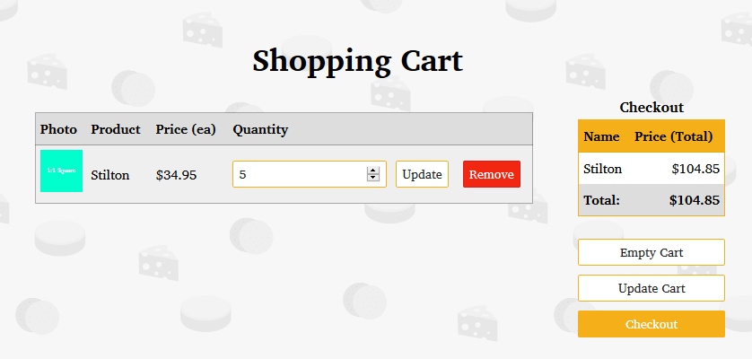

**Clean Up**

With the shopping system all but complete, I finished up the last couple missing features. For price displays, I made sure to format them with two decimal places. I used the PHP function ‘number_format()’ for this. I also updated this in the store-grid template.

Next, I finished off the breadcrumb widget. I decided not to go for a tree system, as that would severely overcomplicate the navigation, and instead appended the name of the current page after a link to the shop page. The breadcrumb widget can be seen below:

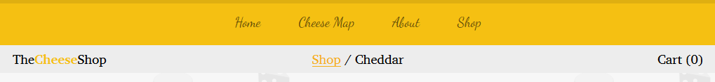*Note that the current page name for item.php adapts to whatever the current cheese is. This also applies to the title element, which shows in the tab of the browser.*

For the ‘Cheese Facts’ section on the item page, I wired up the backend database. I used origin, flavour, and milk type as the ‘facts’. I also changed the background to white, and made the quick facts bar a light grey for better contrast.

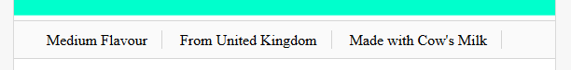

This helps address many of the ethical responsibilities the artisan producer might have, by disclosing what type of milk is used in the cheese. As some cultures consider certain animals, such as Cows, to be sacred, it is important to disclose upfront the contents of the cheese.

**Admin Page & Images**

The final feature missing from the shopping system is the ability to add images. To do this in a sane to use manner, I decided to create an admin page for quickly adding cheeses. This page will then generate a unique identifier for the image and store it in the database. The website can then pull that image through the unique identifier. I decided to enforce a few rules about images:

* Must be in Portable Network Graphic Format (PNG)
* Must be less than 2 MB

I created a new folder inside public which I called ‘admin’. Inside here, I created ‘portal.php’, which is an admin portal for accessing the database. It contains a log-in screen for entering a username and password predefined in config.php, which is then saved as a session variable, while the user manipulates the database. When they log out, this variable is unset. I also added an ‘admin.php’ file in the public directory to redirect the user.

Both the login and admin views are contained within the same file and look as follows:

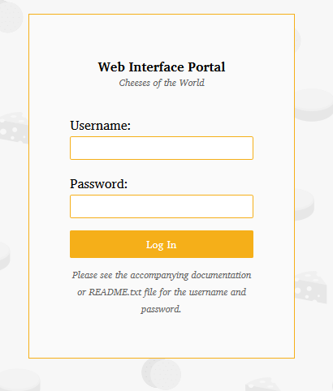

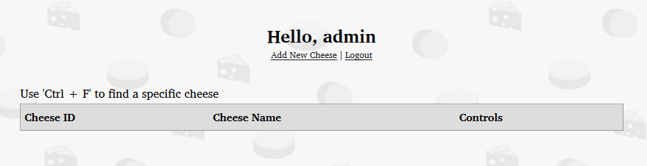

I then populated the main table with a list of every cheese in the database. In the controls column, I added options to edit and remove the item from the database. These buttons are HTML forms which open another PHP page and pass parameters to it. I created edit.php and remove.php to handle these functions. The final admin table can be seen below:

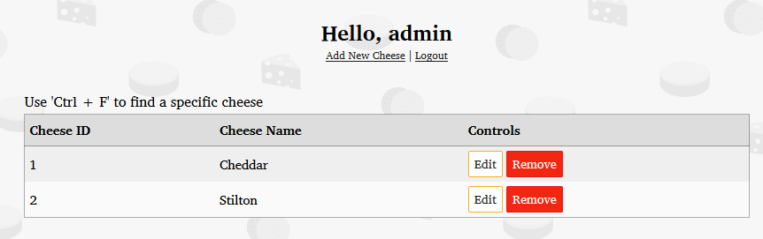

**New, Edit, and Remove**

I then worked on the new, edit, and remove pages. These pages are split into two parts: a php page which is rendered in the browser, and a php script which executes the task and updates the database. I made use of the PHP file upload feature to upload an image file to the website, placing this script in a template file called ‘image.php’. I added a text field to TCheeses which contains the name of the image. For image names, I appended the current UNIX system time (seconds since 1970) to the cheese_id guaranteeing unique file names for all images.

I completed New first, and tested its ability to add to the database. I then duplicated the file and created the edit page. This functions almost identically, except that the record is updated, rather than added. For the page itself, I passed the cheese id by GET, and then pulled in the remaining fields through MySQL. I updated the fields to display these contents. For the image, as the file path cannot be preset for security reasons, I added a checkbox called ‘Update Image’, and used CSS to hide the image file input when the checkbox is deselected.

For all of the ‘admin’ files which provide special privileges, I added a form of authentication that immediately redirects the user to the login if the correct session variables are not set.

**Filling in the Database**

I started to populate the database with images. For pictures of cheese, I used the WikiMedia Commons and licensed them under CC Attribution-SA 3.0 license, in which I must give attribution for the use of images. I will provide this information at the bottom of the about page.

**Remove**

Finally, I finished off the remove page. This is the last major feature of the shopping system. It simply consists of a button asking the user if they are certain they want to delete the item.

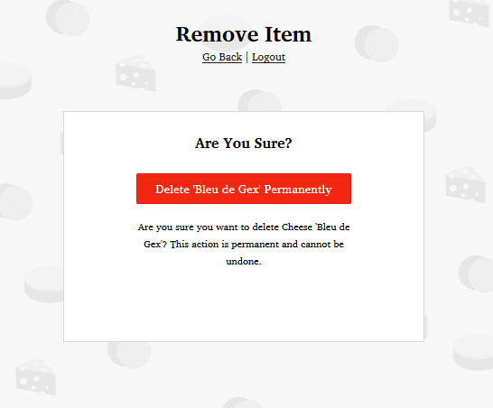

**Bug Fixing**

I encountered a few issues with the database. Firstly, the Cart Add allowed for negative quantities, and Quantity added rather than set the quantity. I fixed this by checking that the quantity was positive before adding, and duplicated cart-add to make cart-quantity.

I also encountered an issue with the image upload system, where the images would become corrupted or not be uploaded at all, while still showing the correct result. I fixed this by adjusting the function to have proper error reporting, and also printed out an error message if the file upload could not occur.

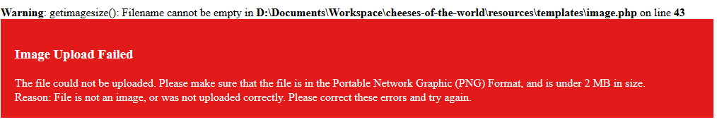*Example Error Message*

**Database Entry**

With this done, I proceeded to fill in the data for the production database. I used the Wikimedia Commons to find images, and recorded the appropriate attribution in a text file. I will add this text file to the website in the next sprint. I obtained nearly all of the images from Wikimedia commons, with the exception of a few, including one I took myself. In total, I added 25 cheeses, with images, to the database.

For attribution, I created a new page, with a table. I input the data attribution data into this table, with anchor elements for linking. Finally, I placed a link to this page in the attribution section of the footer.

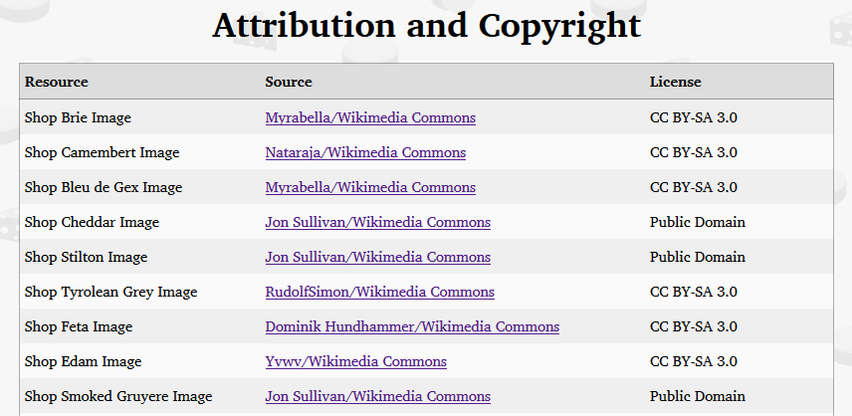

**Clean Up II**

I went through all of the files to search for references to internal functions, and wrapped the remaining in non internal functions in config.php. This means that I can easily address API changes or extensions in the future without having to rewrite a large portion of the website.

Finally, I added error handling for the image lookup service. If an image cannot be found, the following image will be displayed:



Sprint Three

Interactive World Cheese Map

*This sprint will involve using the database from the previous sprint to create an IWCM, which will essentially get the user to browse the store front in a fun and interactive way.*

In order to feasibly create multiple image maps, in any reasonable period of time, I realised that I needed a tool to create these quickly. While I found several online websites claiming to do this, many of them did not work in my browser, and none of them supported images over a certain size. I decided to create my own tool for rapidly creating image maps. I used a combination of Rust and GTK3 to achieve this. I created an array of ‘Areas’, each of which represents a CSS/HTML target area. I created a GUI for adding these with an image overlay for reference. I added serialisation and deseriasation to JSON for saving. The image editor, named ‘Rockhopper’ (after the penguin), looks as follows:

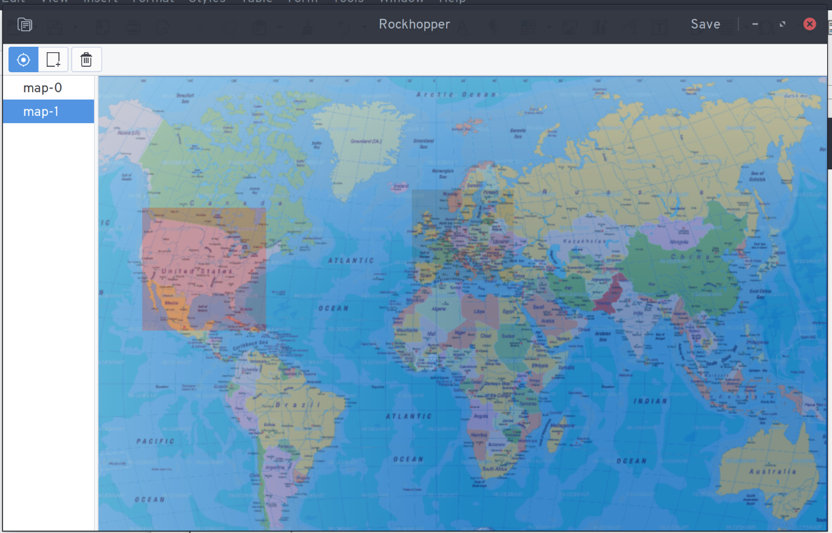

It creates a series of unique CSS IDs, with the prefix ‘map-’ and then a number. It then can build the JSON project file into CSS and HTML. I created an image map of the world, using a CC-BY-SA licensed map from the Wikimedia Commons. I then found regional maps for each Region I had specified earlier, and added the location of a select few cheeses. Upon clicking on these cheeses, the user will be redirected to the storefront. The HTML/CSS generated by the tool creates the following page:

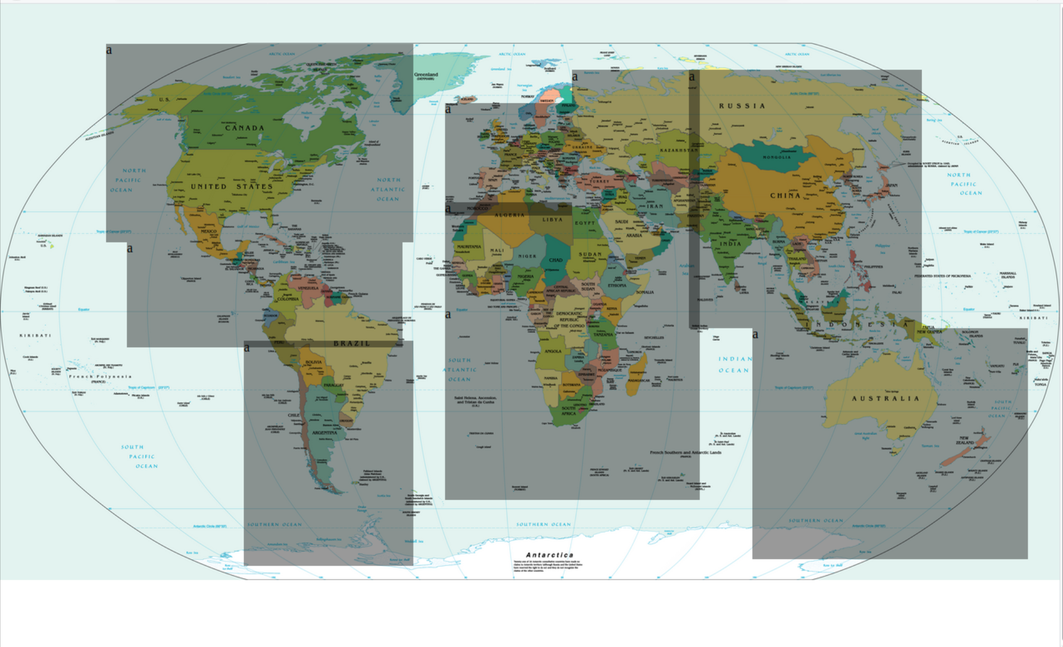

Using this, I created eight more maps for each of the eight regions. I manually set the link hrefs fo reach of the elements to go to the region pages (for the world map) or to the storefront (for the region pages).

For the images, I used a single ‘Political World Map’ from the CIA Factbook via Wikimedia Commons. I exported this as several cropped PNGs using GIMP, and compressed the output using FastStone Photo Resizer so that they were of a suitable size, and also so that they would cause minimal lag to the program. I then created the image maps.

I placed the image maps as php files inside a /map folder, and created a map.php file which includes the correct file based on the get variable ‘map’. The image maps currently look as follows (Asia):

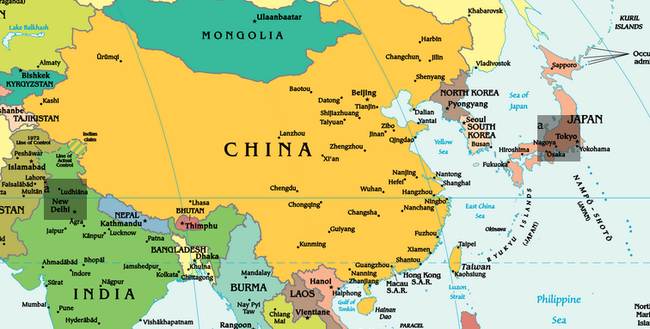

Where the dark coloured rectangles are, I wanted to have a yellow cheese icon. I used the cheese icon from the background and made it yellow, provided a consistent branding for the company, and familiarity to the users. Finally, I added a black circle behind the icon for clarity. The map looks like follows:

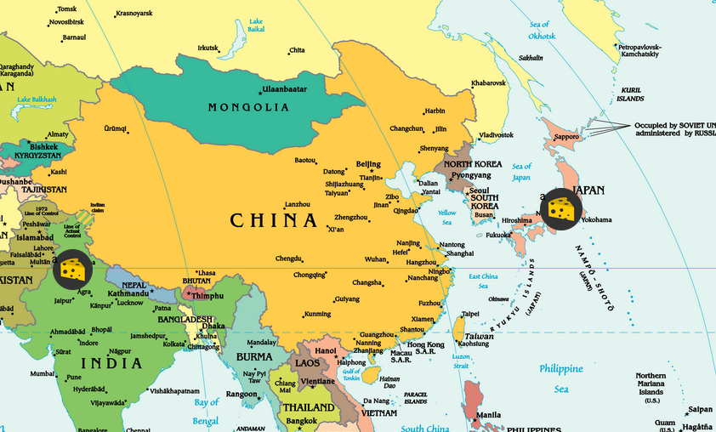

I set up the links for each item to go to its respective store page. I also setup the footer to link to the correct map page. I added the map, from the CIA World Factbook, to my attribution page.

Finally, I decided to add a helper, informing the user that the map is interactive and that they can click on things. I created this in Inkscape and added it to the original image. I positioned it in the top-left corner of the screen, purposely over the Asia click area, so that the user will discover how the map exploration works if they hover over it. It can be seen below.

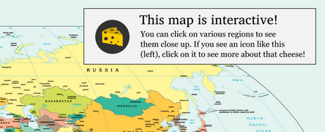

Sprint Four

Polish & Compliance

*This sprint will involve the final implementation of features and content to make the website fully satisfy the criteria provided in the Achievement Standard.*

In this Sprint, I will finish off the remaining features and polish for the website. I first started by making the website better scale to different devices. I started by fixing the navigation bar, which is currently dependent on screen height. As this badly distorts the nav bar on larger displays, and cuts it off completely on smaller ones, I switched to a fixed-height model. I used the CSS ‘calc()’ function to determine the size of the home splash screen.

Next, I set the menu tag to have a max width of 1000px at large screen sizes, and made some minor tweaks. I also set a minimum width in the main style sheet of 650px, as this website is supposed to be viewed on a desktop computer. I added a padding of 12vw on the bottom of every main element to ensure that the footer will always appear at the bottom of the screen. Finally, I resized the main logo and explore button on the splash screen to be smaller.

**Compliance**

Next, I revisited the Achievement Standard to fill in the gaps in the website.

*Requirement 1: Background Information about the company*

In the about page, I filled in the ‘History of Cheese’ section, which I renamed to ‘Our History’. In here, I created a (humorous) backstory about the origins of the company, and its mission to make the world’s greatest cheese.

*Requirement 2: Location and Contact Details*

I then updated the Contact Us section of the about page to contain information about the company, and a short description of where it is located, and how to get in touch. I also added a message encouraging the user to stop by the company’s headquarters and ‘say hello’.

*Requirement 3: Branding (logo, colours, fonts)*

I did not have to do anything here, as I had already designed a company logo, chosen a colour scheme (yellow and white), and determined ‘company fonts’. Additionally, I had created a background pattern consisting of three recurring motifs; the cheese wheel, cheese slice, and cracker. This emphasises the brand’s identity as a cheese producer.

*Requirement 4/5: Images and a list of products with descriptions and prices/Stockists or Purchase Systems*

Again, I had already completed these two sections, with the shopping system, and cart system respectively. The image lookup system which associates an image with a database record satisfies the need for images, and allows for them to be dynamically added and managed from a web interface.

*Requirement 6: Recipes*

For this section, I duplicated the about page and made a new page called recipes. I added this page to the main navigation, and added a selection of recipes for customers to enjoy. For the hero-image, I added a short description of the page, as well as referenced the company’s own cheeses. I decided to mention that using the company’s cheeses was not required, but encouraged it. This will not pressure the users to buy immediately, but rather to try the recipes and feel encouraged to buy from the store. It also helps generate positive PR for the company with users. The hero-image is as follows:

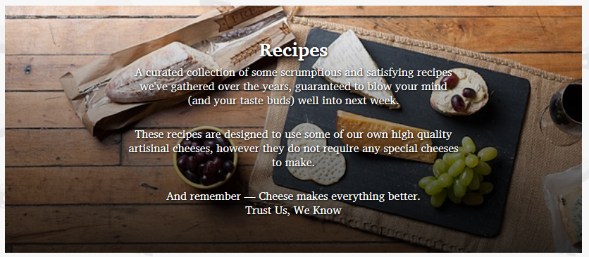

For the recipes themselves, I decided to use a dual pane layout, where one pane contains the recipe, and the other contains an image of what the recipe makes. For the recipes themselves, I took them from Wikibooks.org, licensed under the Creative Commons Attribution-ShareAlike 3.0 (CC BY-SA 3.0), which can be seen at: <https://creativecommons.org/licenses/by-sa/3.0/>. I will add this copyright information to the about page or an attribution page at the end of this sprint.

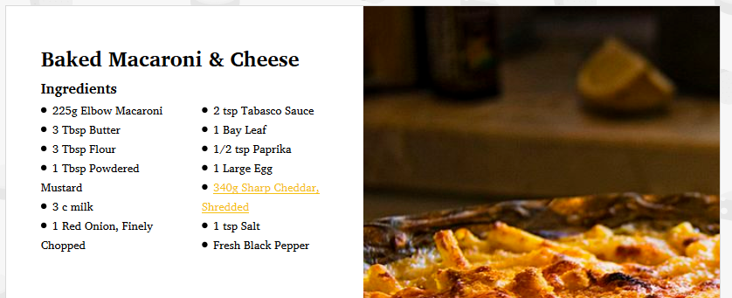

I made the ingredients take up two columns, so that everything would fit inside the div. I also added a link for the cheese used in the recipe, which redirects the user to the store page for that item. I added two recipes total. Finally, I added a link to this page in the footer.

The two recipes I used were:

<https://en.wikibooks.org/wiki/Cookbook:Macaroni_%26_Cheese_(Baked>)

<https://en.wikibooks.org/wiki/Cookbook:Cheese_Dumplings>

I also added Tyrolean Grey Cheese to the shop database.

*Requirement 7: Media Coverage and/or Awards*

For the final requirement, I decided to add a ‘featured on’ bar. As opposed to having awards, which I felt would disrupt the flow of the page, I instead opted to have a media coverage bar which shows that this company has been featured on various news outlets. I created the following mockup of what I wanted the featured bar to look like:

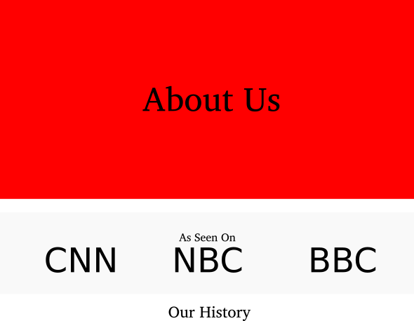

For the News companies themselves, I will create fictional ones to avoid copyright issues. I came up with three cheese-related news companies:

* CNN – Cheese News Network
* NYT – New York Turophiles
* NBC – Nutty Blue Cheese

(Turophile is a lover of cheese)

I created logos for each company in Inkscape, and added them to the coverage bar as follows:



I added padding to the three images in conjunction with border-box to make the images smaller and to have more ‘breathing room’.

**Commenting & Validation**

Next, I organised and validated my work. For CSS, I shifted around various selectors to form groups for General Styling, and Per-Page Styling. I then added comments indicating what each section is for. I validated the CSS and fixed any errors that popped up.

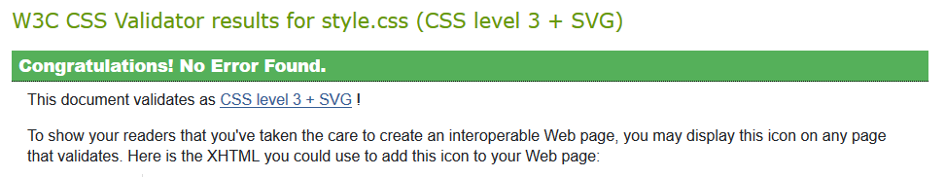*CSS Stylesheet Validated*

I was unable to validate the HTML using W3C’s validation tool, as it is tightly interweaved with PHP. Instead, I thoroughly tested the website in the following browsers, checking for any display issues:

* Chrome
* Edge
* Opera

As I had developed the website in Firefox, I could already confirm that it displayed exactly as intended.

**PHP Checker**

I added a small script to the index.php page which will not run on normal execution, but be displayed if PHP is disabled. I added some tips on how to set up the web server here. It can be seen as follows:

**Submission**

Now complete, I exported the database as SQL. I added instructions on how to setup the website in a README.txt file in the root directory. I finished by converting this file, which was written in LibreOffice Writer to DOCX (Word Document) for more accessible reading, and by zipping the submission in a compressed folder.

**By Matthew Jakeman**

*Finished 13/08/2018*